MATH 243 — Probability and Statistics
Introduction, Frequency Distributions and Graphical Representation
Lesson notes · Exam approach · TF practice with solutions · Quick notes (Statistics portion)

How to Read These Notes
EXAM FOCUS | Exam importance, where it appears in the TF collection
MEMORIZE | Rules, tables and formulas to memorize
TRAP | Common mistakes and exam traps
EXAM-READY ANSWER | Model wording you can write in the exam
NOTE | Extra explanation / clarification
Grey box, monospace | Code, worked tables, derivations and hand-drawn sketches
Centered grey box | Formula to remember / final numerical result
Purple heading / ✔ green | Practice questions / their solutions

Contents
Exam Map — What the TF Papers Ask — data, frequency tables, stem-and-leaf, diagrams
Lesson 1 — Statistics, Data, Variables and Sampling — descriptive vs inferential, scales, sampling methods
Lesson 2 — Grouped Frequency Distributions — classes, Sturges' rule, boundaries, cumulative frequency
Lesson 3 — Histogram, Frequency Polygon, Ogive and Other Charts — graphs, reading the median from the ogive, shapes
Lesson 4 — Stem-and-Leaf Plots, Five-Number Summary and Boxplots — stem-and-leaf, quartiles, boxplot, outliers
Quick Notes — Introduction and Graphs — revision bullets
NOTE The four decks are scanned textbook pages (Bluman, Elementary Statistics). Page numbers: 1.1 Stat L1.pdf (15 pp.) = "L1 p.", 1.2 Stat L2.pdf (5 pp.) = "L2 p.", 5. Graphical Representation Stat.pdf (11 pp.) = "G1 p.", 6. Graphical representation 2.pdf (18 pp.) = "G2 p.". "TF p." = merged question PDF page; "22 batch p." = 2023-24 paper.

Exam Map — What the TF Papers Ask
Session (paper) | Questions answered by this note [lesson]
2023-24 (MATH 243)  TF p. 22 batch p.3 | Q5(a) What is a stem-and-leaf plot; how to create one, with an example (10) [L4]
2022-23 (MATH 243)  TF p. 49, 50 | Q5(a) Statistical data: meaning, how produced, why needed, sources in Bangladesh (10) [L1] · Q5(b) Insulation thickness (60 values): frequency table by Sturges' rule; histogram and cumulative frequency graph (15) [L2] · Q6(b) Lengths of 12 pencils: stem-and-leaf plot; median, mode, range (10) [L4]
2021-22 (MATH 245)  TF p. 44 | Q5(b) (i) 34 observations 201–337, 7 classes of width 20 from 199.5: class limits and marks; (ii) same mean, SD, skewness — kurtosis (17) [L2]

EXAM FOCUS 5 questions, 62 marks — all from 2021-22 onward, so this "easy" deck is now a regular Section B opener: build a frequency table with Sturges' rule and draw the histogram/ogive (15 marks), a stem-and-leaf plot with median/mode/range (10), and short theory on statistical data. Graph-reading (median from the ogive) is also asked — see Lesson 6 of the Central Tendency note.

Lesson 1 — Statistics, Data, Variables and Sampling
L1 pp. 1–15

1. Basic Terms (L1 pp. 1–2)
- Statistics — the science of conducting studies to collect, organise, summarise, analyse and draw conclusions from data.
- Variable — a characteristic that can take different values; data — the values (measurements or observations) a variable takes; a data set is a collection of data values, each one a datum. Random variables — variables whose values are determined by chance.
- Population — all subjects being studied; census — data from every subject; sample — a group of subjects selected from the population. A sample that does not represent the population is biased.

2. Descriptive and Inferential Statistics (L1 pp. 3–4)
- Descriptive statistics — collection, organisation, summarisation and presentation of data (e.g. the census results as averages, charts, tables).
- Inferential statistics — generalising from samples to populations: estimation, hypothesis testing, relationships among variables, prediction. It uses probability.
- Example 1-1: average lottery jackpot → descriptive; "older people on a high-calorie diet double their memory loss risk" → inferential; average Valentine's spending from 9317 consumers → descriptive; laughter and pain tolerance → inferential.

3. Types of Variables (L1 pp. 5–6)
Variables
├─ Qualitative (categorical: gender, religion, location)
└─ Quantitative (counted or measured: age, height, weight)
├─ Discrete (countable: children in a family, calls per day)
└─ Continuous (measured, any value in an interval: temperature, weight)

Example 1-2: hurricane wind speed — continuous; baggage weight — continuous; pages in a book — discrete; money spent — discrete (smallest unit is a cent).

4. Levels of Measurement (L1 pp. 7–9)
Level | Property | Examples
Nominal | mutually exclusive categories, no order | zip code, gender, colour, religion
Ordinal | ordered categories; differences not precise | grades A–F, small/medium/large, rankings
Interval | precise differences; no true zero | temperature (°F), IQ
Ratio | interval + true zero; ratios meaningful | height, weight, age, salary

Example 1-4: ages of patients — ratio; movie ratings — ordinal; shirt colours — nominal; hot-tub temperatures — interval.

5. Sampling Methods (L1 pp. 10–15)
Method | How the sample is chosen
Random | every member has an equal chance; numbered population + random numbers (table or computer)
Systematic | number the population, pick a random start in 1…k, then every k-th member (k = N/n, e.g. 2000/50 = 40)
Stratified | divide into subgroups (strata) by a relevant characteristic, then randomly sample from each stratum
Cluster | divide into clusters (e.g. areas, buildings), randomly select whole clusters and use all their members

Example 1-5: records from one of 10 hospitals — cluster; students grouped by gender, major and GPA then sampled — stratified; numbered subscribers + random numbers — random; every 10th bottle — systematic. Sampling error is the difference between a sample result and the population result.
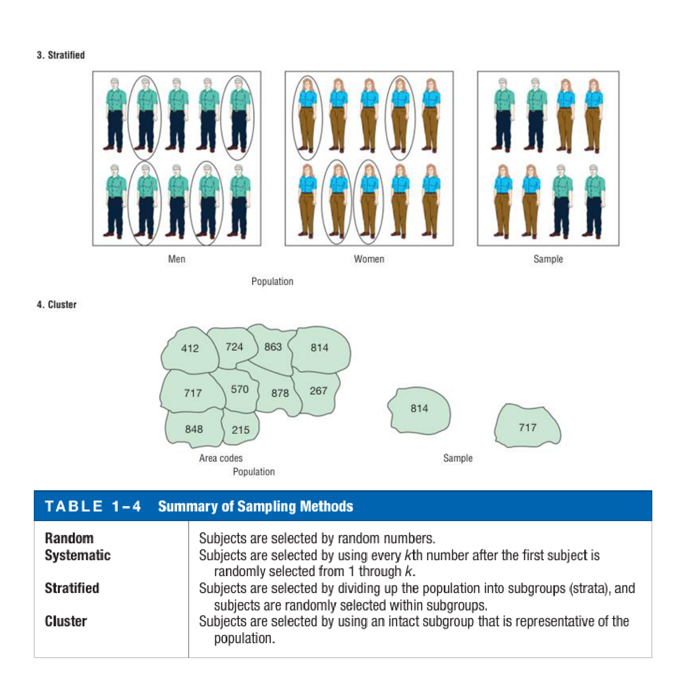
Figure 1.1 — Stratified and cluster sampling, with the summary of sampling methods (L1 p. 14)

6. Statistical Data and their Sources (textbook — 2022-23 Q5(a))
EXAM-READY ANSWER Statistical data are numerical facts collected in a systematic way for a definite purpose, in a form that can be compared and analysed (aggregates, not single isolated figures). They are produced by censuses, sample surveys, experiments and the administrative records of organisations; data collected first-hand are primary, data taken from published sources are secondary. We need them to describe a situation, compare groups, find relationships, forecast and make policy and business decisions on evidence instead of guesswork. Usual sources in Bangladesh: the Bangladesh Bureau of Statistics (Population and Housing Census, Household Income and Expenditure Survey, Labour Force Survey, Statistical Yearbook), Bangladesh Bank (monetary and trade statistics), ministries and directorates (DGHS health bulletins, Ministry of Education/BANBEIS), BIDS and other research institutes, BDHS (demographic and health survey), and international bodies (World Bank, UN agencies).

Practice — Lesson 1
(a) Actual — 2022-23 Q5(a) (TF p. 49). (b) Adapted — L1 p. 15 Example 1-5.
(a) What do you mean by statistical data? How are they produced? Why do you need statistical data? What are the usual sources of statistical data in Bangladesh? (10)
(b) Explain stratified random sampling with an example.

✔ Solution
(a) Model answer in §6.
(b) The population is divided into non-overlapping, internally similar subgroups (strata) and a simple random sample is drawn from each stratum, usually in proportion to its size. Example: to estimate average delivery time of an online medicine shop, divide orders by zone (Dhaka North, Dhaka South, outside Dhaka) and randomly select orders from each zone, so every zone is represented. (Asked with a z-test in 2023-24 Q6(c).)

Lesson 2 — Grouped Frequency Distributions
L2 pp. 2–5

1. Constructing a Grouped Frequency Distribution (L2 pp. 2–4)
1. Range R = highest − lowest value.
2. Choose the number of classes k (5–20; Sturges' rule k = 1 + 3.322 log₁₀ N).
3. Width = R/k, rounded up (4.9 → 5).
4. Start at the lowest value (or a convenient number below it); lower limits go up by the width; upper limit = next lower limit − 1 unit.
5. Class boundaries = limits ± 0.5 unit (no gaps). Class mark (midpoint) = (lower + upper)/2.
6. Tally, count the frequencies, check that they total N.
Example 2-2 — record high temperatures of the 50 states, 7 classes: H = 134, L = 100, R = 34, width = 34/7 = 4.9 → 5.
Class limits | Boundaries | Frequency | Cumulative (less than upper boundary)
100–104 | 99.5–104.5 | 2 | 2
105–109 | 104.5–109.5 | 8 | 10
110–114 | 109.5–114.5 | 18 | 28
115–119 | 114.5–119.5 | 13 | 41
120–124 | 119.5–124.5 | 7 | 48
125–129 | 124.5–129.5 | 1 | 49
130–134 | 129.5–134.5 | 1 | 50

2. Cumulative Frequency (L2 pp. 4–5)
Cumulative frequency = number of values less than or equal to a class's upper boundary (running total). Here 28 temperatures are ≤ 114.5 °F and 48 are ≤ 124.5 °F. When the range is small, an ungrouped distribution (one value per class) is used instead.

Exam Approach
1. N, min, max, R; k by Sturges (round to a whole number); width = R/k rounded up.
2. Write limits, boundaries and class marks in one table; tally; total = N.
3. Add a cumulative-frequency column if a cumulative graph is asked.

Practice — Lesson 2
(a) Actual — 2022-23 Q5(b) (TF p. 49). (b) Actual — 2021-22 Q5(b) (TF p. 44).
(a) The thickness (mm) of insulation in 60 transformer windings is recorded (table on TF p. 49). (i) Make a frequency table using Sturges' rule K = 1 + 3.322 log N. (ii) Draw a frequency histogram and a cumulative frequency graph. (15)
(b) (i) A sample of 34 observations recorded to the nearest integer ranges from 201 to 337. Seven classes of width 20 are used, the first beginning at 199.5: find the class limits and class marks. (ii) Two distributions have the same mean, SD and skewness. Find (comment on) their kurtosis. (17)

✔ Solution
(a) N = 60, smallest 18, largest 57, R = 39. K = 1 + 3.322 log 60 = 1 + 3.322(1.7782) = 6.91 ≈ 7 classes; width = 39/7 = 5.57 → 6. Start at 18 (boundary 17.5).
Limits | Boundaries | Class mark | Frequency | Cumulative
18–23 | 17.5–23.5 | 20.5 | 4 | 4
24–29 | 23.5–29.5 | 26.5 | 5 | 9
30–35 | 29.5–35.5 | 32.5 | 10 | 19
36–41 | 35.5–41.5 | 38.5 | 25 | 44
42–47 | 41.5–47.5 | 44.5 | 9 | 53
48–53 | 47.5–53.5 | 50.5 | 3 | 56
54–59 | 53.5–59.5 | 56.5 | 4 | 60
Total |  |  | 60

(ii) Histogram: boundaries 17.5, 23.5, …, 59.5 on the x-axis, bars of heights 4, 5, 10, 25, 9, 3, 4 with no gaps. Cumulative frequency graph (ogive): plot (17.5, 0), (23.5, 4), (29.5, 9), (35.5, 19), (41.5, 44), (47.5, 53), (53.5, 56), (59.5, 60) and join by straight lines. The distribution peaks in 35.5–41.5 mm.
Freq
25 | ████
20 | ████
15 | ████
10 | ████ ████
5 | ████ ████ ████ ████ ████
0 +─████─████─████─████─████─████─████──→ thickness (mm)
17.5 23.5 29.5 35.5 41.5 47.5 53.5 59.5

(b) (i) Boundaries 199.5–219.5, 219.5–239.5, …, 319.5–339.5; class limits 200–219, 220–239, 240–259, 260–279, 280–299, 300–319, 320–339; class marks 209.5, 229.5, 249.5, 269.5, 289.5, 309.5, 329.5 (the range 201–337 fits inside).
(ii) Mean, SD and skewness fix the location, spread and symmetry only. Kurtosis β₂ = μ₄/μ₂² depends on the fourth moment, which these three measures do not determine, so the two distributions can still differ in peakedness: one may be leptokurtic (β₂ > 3) and the other platykurtic (β₂ < 3). Compute β₂ for each to compare (see the Skewness, Moments and Kurtosis note).

Lesson 3 — Histogram, Frequency Polygon, Ogive and Other Charts
G1 pp. 1–11 · G2 pp. 1–8

1. The Three Basic Graphs (G1 pp. 1–5)
- Histogram — contiguous vertical bars on the class boundaries; heights = frequencies.
- Frequency polygon — points (class midpoint, frequency) joined by lines; close it on the x-axis one class width beyond each end.
- Ogive (cumulative frequency graph) — points (upper boundary, cumulative frequency), starting at (first lower boundary, 0). Read "how many below x" by going up from x to the curve and across.
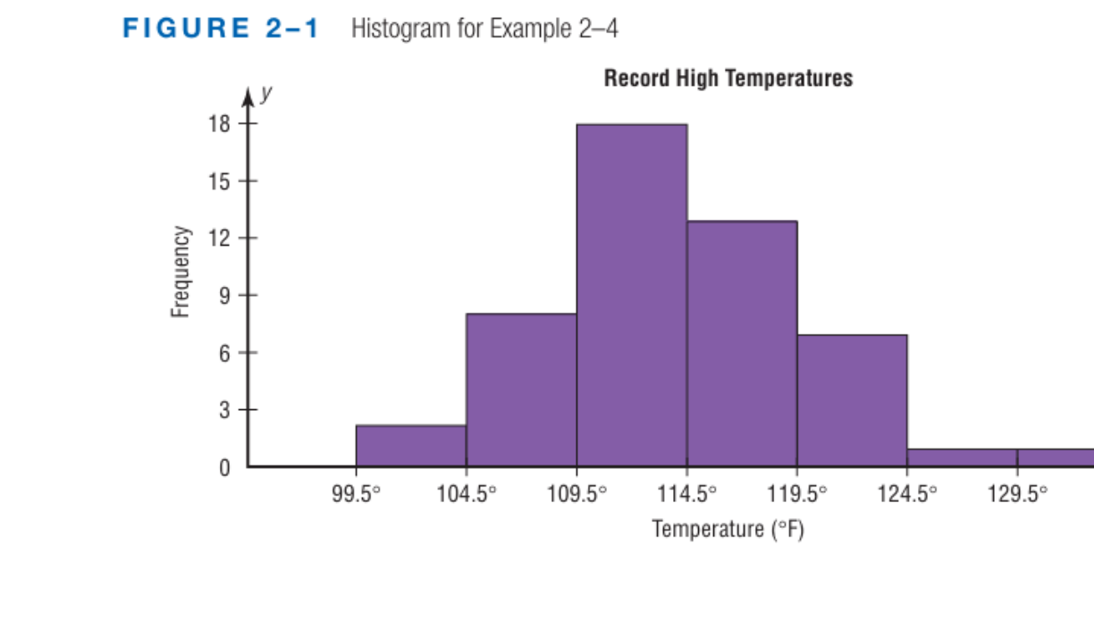
Figure 3.1 — Histogram of the record high temperatures (G1 p. 1)
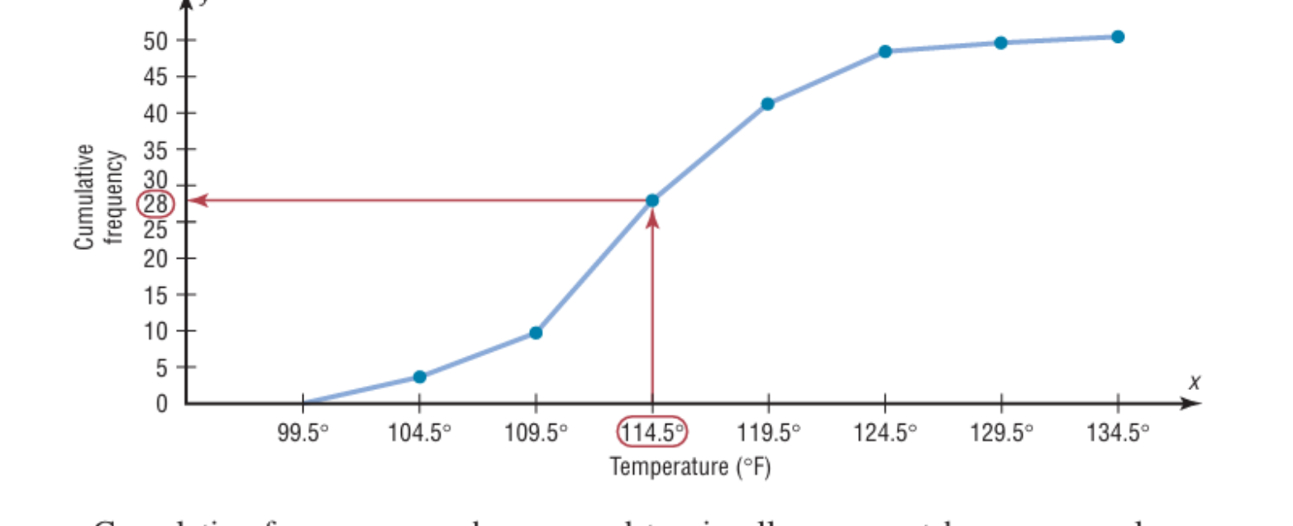
Figure 3.2 — Ogive; 28 values lie below 114.5 °F (G1 p. 5)

2. Relative Frequency Graphs (G1 pp. 6–9)
Divide each frequency by N (proportions summing to 1) and draw the same three graphs; used to compare data sets of different sizes. Runners' miles (N = 20): relative frequencies 0.05, 0.10, 0.15, 0.25, 0.20, 0.15, 0.10; cumulative 0.05, 0.15, 0.30, 0.55, 0.75, 0.90, 1.00.

3. Distribution Shapes (G1 pp. 9–11)
Bell-shaped, uniform, J-shaped, reverse J-shaped, right (positively) skewed — tail to the right, left (negatively) skewed, bimodal, U-shaped. Look for peaks, gaps, outliers and the side of the longer tail.
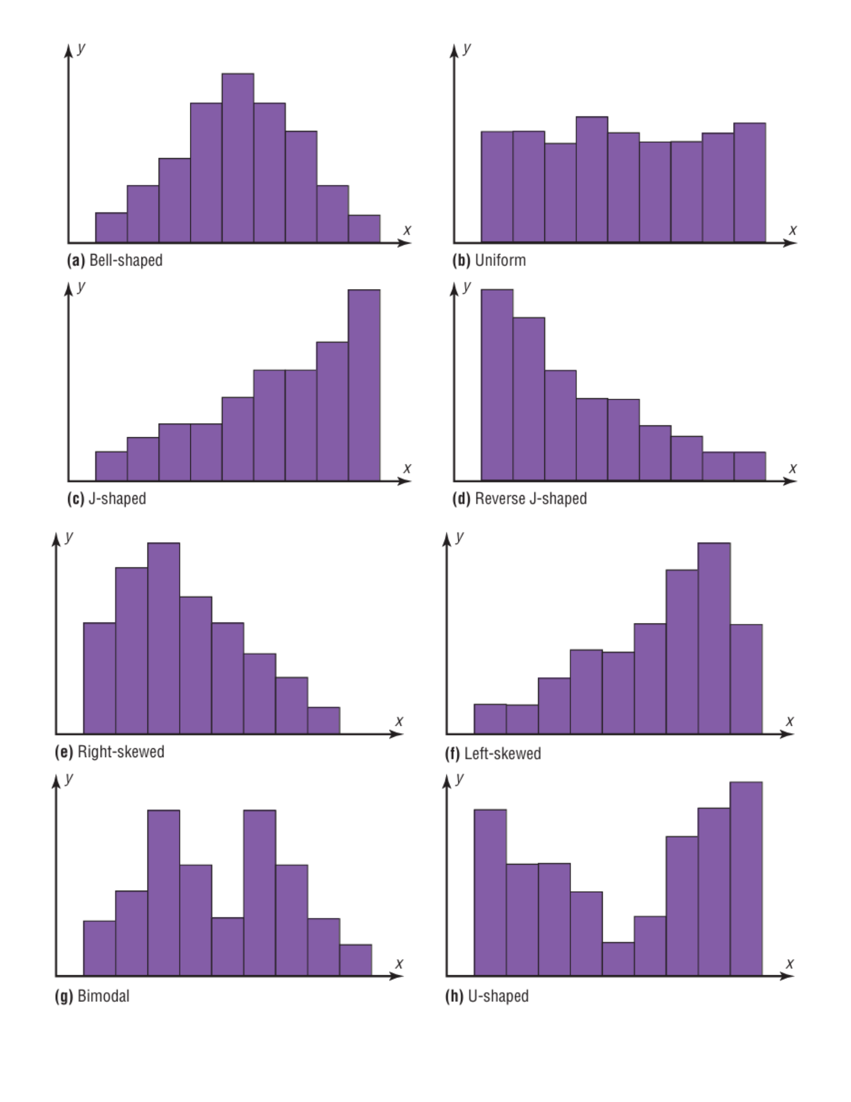
Figure 3.3 — Distribution shapes (G1 p. 10)

4. Other Graphs (G2 pp. 1–8)
Graph | Use / construction
Bar graph | categorical data; bars separated, horizontal or vertical
Pareto chart | categorical frequencies as bars arranged from largest to smallest (police calls)
Time series graph | data over time, points joined in order; compound graph for two series
Pie graph | parts of a whole; angle = (f/n) × 360°, % = (f/n) × 100 (snack foods 134°, 98°, 52°, 46°, 30°)
Dotplot | each value as a dot above a number line; repeats stacked (named storms)

5. Scatter Plot (textbook; asked 2023-24 Q5(b))
For paired quantitative data (x, y): plot each pair as a point. The pattern shows the direction (positive/negative), form (linear/curved) and strength of the relationship and any outliers. It is the first step of correlation analysis (Correlation & Regression note).

Exam Approach
1. Histogram/polygon/ogive: use boundaries (histogram, ogive) or midpoints (polygon) — label both axes.
2. Ogive median: locate N/2 on the y-axis, go across to the curve and down to the x-axis.
3. Pie: angles must sum to 360°. Scatter: one point per pair, then describe direction and strength.

Practice — Lesson 3
(a) Actual — 2023-24 Q5(b) (22 batch p. 3).
(a) Explain the scatter plot briefly with an example. Prices ($) and ratings (out of 5) of 5 restaurants: A (22, 3.5), B (29, 4.0), C (15, 3.0), D (18, 4.0), E (23, 3.5). Plot them and interpret whether there is a relationship between price and rating. (13)

✔ Solution
Rating
4.0 | • D(18) • B(29)
3.5 | • A(22) • E(23)
3.0 | • C(15)
+----+----+----+----+----+----→ Price ($)
15 18 21 24 27 30

The points rise from left to right on the whole: dearer restaurants tend to have higher ratings, a weak-to-moderate positive relationship (r = 0.60). D is an exception (cheap but rated 4.0), so price is not a strong predictor of rating with only five points.

Lesson 4 — Stem-and-Leaf Plots, Five-Number Summary and Boxplots
G2 pp. 8–18

1. Stem-and-Leaf Plot (G2 pp. 8–12)
A stem-and-leaf plot uses part of each value as the stem and the rest as the leaf (34 → stem 3, leaf 4; 356 → 35 | 6). It sorts and graphs the data at once while keeping the actual values.
1. Arrange the data in order (helpful, not essential).
2. Split each value into leading digit(s) = stem and trailing digit = leaf.
3. Write the stems in a column and the leaves (in order) beside them; leave an empty row for a stem with no data.
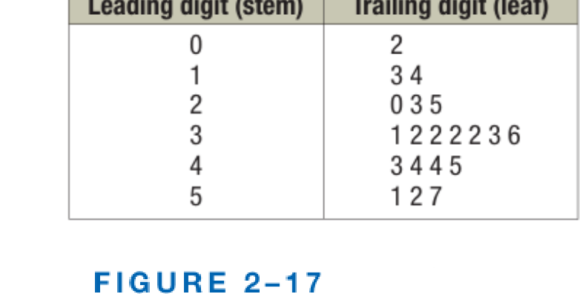
Figure 4.1 — Stem-and-leaf plot of 20 days' cardiograms (G2 p. 10)
Classes of five (Example 2-15: car thefts, stems 5, 5, 6, 6, 7, 7 for 50–54, 55–59, …) and back-to-back plots for two data sets sharing the same stems (Example 2-16: Atlanta vs Philadelphia buildings).

2. Five-Number Summary and Boxplot (G2 pp. 13–18)
Minimum, Q₁, median, Q₃, maximum. Boxplot: a box from Q₁ to Q₃ with a line at the median, whiskers to the minimum and maximum. Meteorites: 30, 39, 47, 48, 78, 89, 138, 164, 215, 296 → median 83.5, Q₁ = 47, Q₃ = 164.
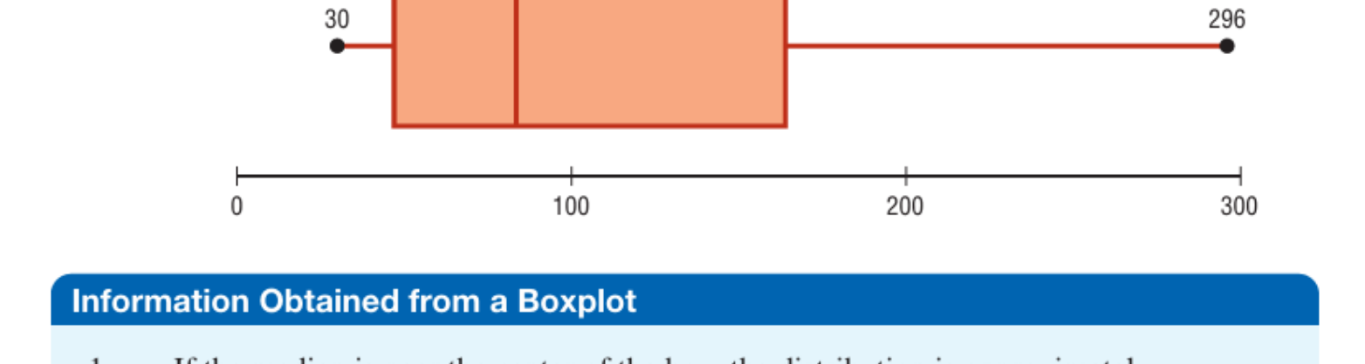
Figure 4.2 — Boxplot for the meteorite data (G2 p. 15)
- Median near the centre of the box and equal whiskers → approximately symmetric.
- Median left of centre / right whisker longer → positively skewed; the opposite → negatively skewed.
- Comparing two boxplots on one axis: medians compare averages, box lengths (IQR) compare variability (real cheese 67.5/200/275 vs substitute 215/265/300).
- Modified boxplot: whiskers stop at the last value within 1.5 IQR; mild outliers lie beyond Q ± 1.5 IQR, extreme outliers beyond Q ± 3 IQR.

Exam Approach
1. Sort the data; choose stems so there are 5–10 rows; write leaves in order; add a key (17 | 2 = 17.2).
2. Median = middle value (average of the two middle ones when n is even); mode = most frequent leaf; range = max − min.
3. Boxplot: five-number summary first, then the scaled axis and the box.

Practice — Lesson 4
(a) Actual — 2022-23 Q6(b) (TF p. 50). (b) Actual — 2023-24 Q5(a) (22 batch p. 3).
(a) Lengths (cm) of 12 pencils: 17.2, 16.4, 18.6, 17.4, 17.5, 19.0, 17.4, 16.8, 19.0, 17.8, 18.8, 18.7. Use a stem-and-leaf plot to display the data. Hence find the median, mode and range. (10)
(b) What do you mean by stem-and-leaf plots? How do you create one? Explain with examples. (10)

✔ Solution
(a) Ordered: 16.4, 16.8, 17.2, 17.4, 17.4, 17.5, 17.8, 18.6, 18.7, 18.8, 19, 19. Stem = whole centimetres, leaf = tenths (key 17 | 2 = 17.2 cm).
16 | 4 8
17 | 2 4 4 5 8
18 | 6 7 8
19 | 0 0

n = 12 (even): median = (6th + 7th)/2 = (17.5 + 17.8)/2 = 17.65 cm. Mode: 17.4 and 19.0 each occur twice → bimodal (17.4 cm and 19.0 cm). Range = 19.0 − 16.4 = 2.6 cm.
(b) Definition and the three steps in §1, with the cardiogram example (Figure 4.1) or the pencil example above. Mention its advantage over a grouped frequency table: the original values are kept.

Quick Notes — Introduction and Graphs
Revision points for Lessons 1–4.

L1 · Basics
- Descriptive = organise/summarise; inferential = sample → population (uses probability).
- Qualitative vs quantitative (discrete/continuous). Nominal < ordinal < interval < ratio (true zero).
- Random, systematic (every k-th), stratified (sample each stratum), cluster (whole groups).

L2 · Frequency Tables
- Sturges k = 1 + 3.322 log N; width = range/k rounded up; boundaries ± 0.5 unit.
- Thickness: k ≈ 7, width 6, f = 4, 5, 10, 25, 9, 3, 4. 34 values 201–337: marks 209.5 … 329.5.

L3 · Graphs
- Histogram (boundaries), polygon (midpoints), ogive (upper boundary, cumulative f).
- Shapes: bell, uniform, J, reverse J, right/left skewed, bimodal, U. Pie angle = f/n × 360°.
- Scatter plot: direction, form, strength; restaurants weakly positive.

L4 · Stem-and-Leaf and Boxplot
- Pencils: 16|4 8, 17|2 4 4 5 8, 18|6 7 8, 19|0 0; median 17.65, modes 17.4 & 19.0, range 2.6.
- Five-number summary → boxplot; outliers beyond 1.5 IQR (mild) and 3 IQR (extreme).

